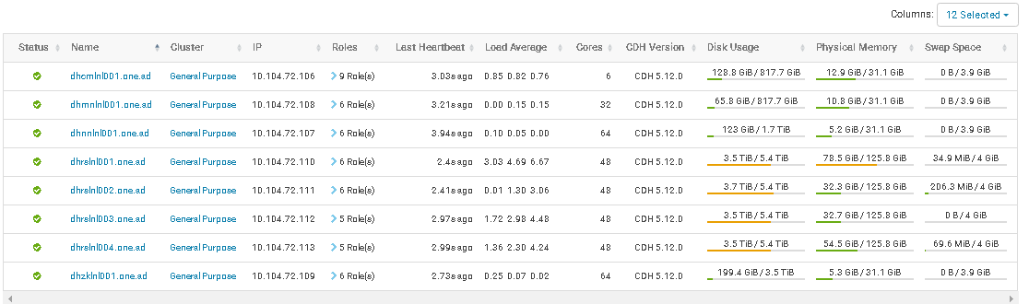

**Container Memory (yarn.nodemanager.resource.memory-mb)=86GiB**

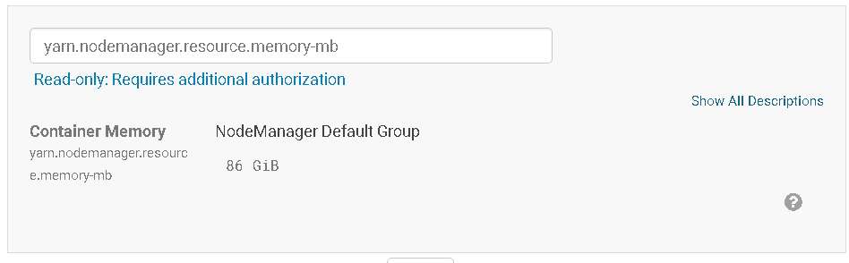

**Map Task Memory (mapreduce.map.memory.mb) = 4GiB**



**Map Task CPU Virtual Cores (mapreduce.map.cpu.vcores) = 1**

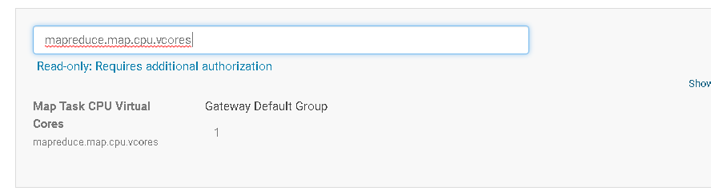

**Reduce Task Memory (mapreduce.reduce.memory.mb) = 4 Gib**

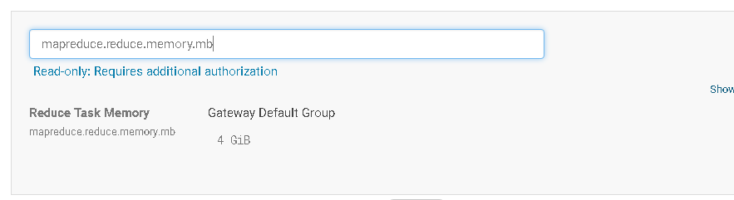

**Reduce Task CPU Virtual Cores (mapreduce.reduce.cpu.vcores) = 1**

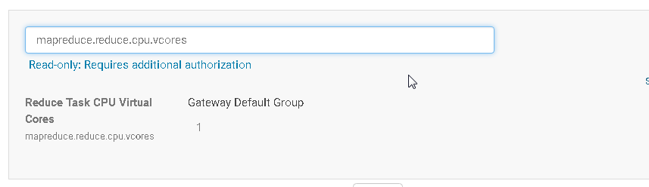

**Map Task Maximum Heap Size (mapreduce.map.java.opts.max.heap) = 0GiB**

**Reduce Task Maximum Heap Size (mapreduce.reduce.java.opts.max.heap) =0GiB**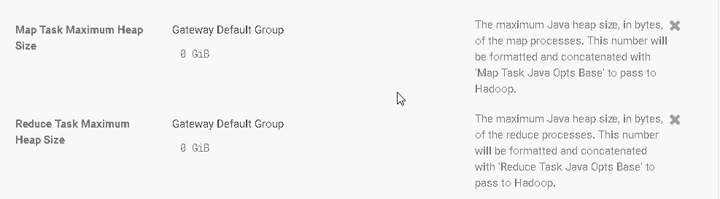

**Client Java Heap Size**



**Container Virtual CPU Cores = 38**

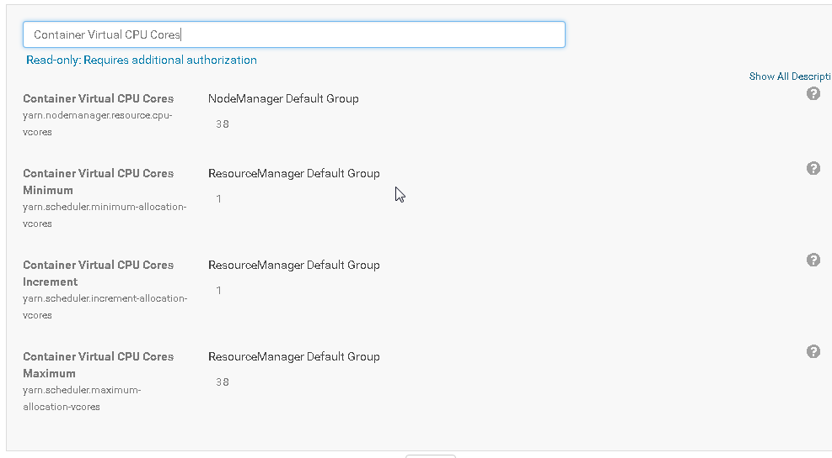

**Container Memory Minimum (yarn.scheduler.minimum-allocation-mb) =  1 GiB**

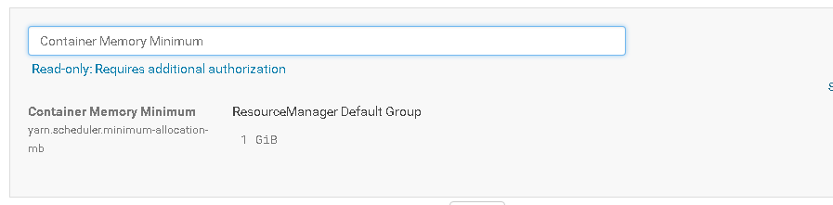

**Container Memory Maximum (yarn.scheduler.maximum-allocation-mb) = 64 GiB**

